DEALS TO MARFA

Deep in the heart of Southern Texas there’s an undiscovered cultural gem. Marfa may be a little desert town with a small population, but don’t let its size fool you. With a permanent collection of works by leading artists such as Donald Judd and Dan Flavin, this town is often seen as the state’s mecca of art. Book a trip to Marfa via Dallas Love Field on Virgin America. Live it up at 35,000 feet with WiFi, on-demand entertainment, and more on every flight.

(MARKET IMAGE HERE)

Find Deals From These Cities

INSERT FARE GRID FROM / TO Version (if available!)

   
Top Things To Do in Marfa

In addition to art, you may be surprised to find several other things to do in Marfa that you’ll really enjoy. See a few of them below.

* See the Marfa Mystery Lights. Since the late 1800’s, strange circular lights have been appearing in Marfa every night and the cause behind the lights has yet to be discovered. If you happen to be visiting over Labor Day Weekend, head to the Marfa Lights Festival to celebrate this phenomenon with events that include live music, food, a parade, and more.
* Soak in the Chinati Hot Springs (the flowing waters rise to about 110 degrees Fahrenheit) for a peaceful and soothing experience you’ll want to come back for. For a great workout, take a hike or bike ride along the trails before treating yourself to a dip in the springs.
* Take a Sunrise Tour or Sunset Tour at the Chinati Foundation to see the works of Donald Judd that are most affected by the light at various times of the day. You’ll be in awe at how the reflection of the sun’s light brings out different aspects in each of the 100 untitled mill aluminum works and 15 concrete pieces.
* Browse the wonderfully varied selection of books at Marfa Book Company. While perusing this gem of a bookstore, grab some coffee in the attached café and stroll through its garden.

Travel Tips and Resources

[Must-Dos in Marfahttp://astateofwander.com/coolest-things-to-do-in-marfa/](http://astateofwander.com/coolest-things-to-do-in-marfa/)

[Marfa Hotels](http://www.tripadvisor.com/Hotels-g56230-Marfa_Texas-Hotels.html)

[Marfa Restaurantshttp://www.visitmarfa.com/dining.php - .VvBgteIrLRY](http://www.visitmarfa.com/dining.php#.VvBgteIrLRY)

[Marfa Shopping Guidehttp://www.visitmarfa.com/shopping.php - .VuXuskvlBrc](http://www.visitmarfa.com/shopping.php#.VuXuskvlBrc)

[Marfa Nightlife and Entertainment](http://www.tripadvisor.com/Attractions-g56230-Activities-c20-t99-Marfa_Texas.html)

[Marfa Travel Tipshttp://www.texasmonthly.com/texas-trip-guides/trip-guide-marfa](http://www.texasmonthly.com/texas-trip-guides/trip-guide-marfa)

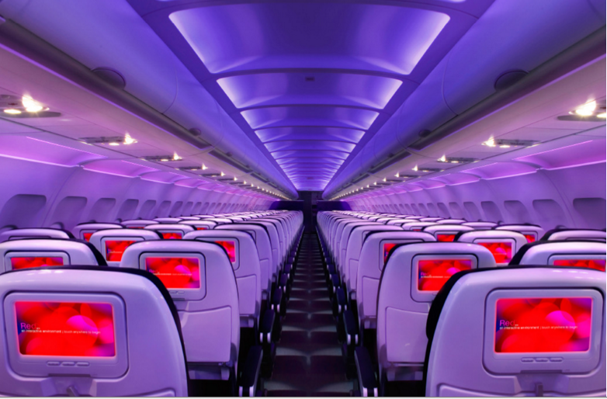

Main Cabin Main Cabin Select First Class

(add links to Cabin Class Pages)

Ready. Set. Fly.

Book your Mood-lit Ride to Marfa.

If you’ve begun researching flights to Marfa, TX, then you’re already aware that you’ll need to rent a car since this desert town is quite a distance from pretty much every place in the state. One of the best ways to travel to Marfa is to fly into Dallas Love Field (DAL) and take the approximately 7 ½ hour drive to Marfa. Along the drive, make a stop at the Buffalo Gap Historic Village or Monahans Sandhills State Park. Book your flight to Dallas with Virgin America to experience all of our amazing in-flight amenities. Take a virtual tour to see just how comfortable and convenient it is to fly with us.

Take a Virtual Tour

Add Terms & Conditions